Detail Assignment
SOAL 1 — Data Loading & Profiling Awal
Perintah 1:
Load keempat CSV menjadi DataFrame Spark dengan schema yang benar (pastikan order_date dan signup_date bertipe date, total_amount, price double, quantity int).
Perintah 2:
Lakukan data profiling ringkas:
- jumlah baris tiap DataFrame,
- cek null per kolom,
- tampilkan 5 contoh baris tiap dataset.
Perintah 3:
Buat “anomaly summary” awal:
- jumlah orders dengan total_amount <= 0,
- jumlah order_items dengan quantity <= 0 atau price <= 0,
- jumlah duplikasi key utama (order_id di orders, product_id di products, user_id di users).
SOAL 2 — Cleaning & Standardization
Perintah 1:
Bersihkan data:
- drop baris orders yang order_id atau user_id null,
- drop baris order_items yang order_id atau product_id null,
- drop baris products yang product_id null,
- drop baris users yang user_id null.
Perintah 2:
Standardisasi kolom teks:
- city di users → lowercase + trim,
- category di products → lowercase + trim.
Perintah 3:
Deduplication berbasis key:
- orders dedupe by order_id,
- order_items dedupe by kombinasi (order_id,product_id),
- products dedupe by product_id,
- users dedupe by user_id. Tunjukkan jumlah baris sebelum vs sesudah dedupe.
SOAL 3 — Data Enrichment & Feature Engineering
Perintah 1:
Di order_items, buat kolom turunan:
- total_item_value = quantity * price.
Perintah 2:
Di orders, buat kolom kategorisasi menggunakan when/otherwise:
- order_value_flag dengan aturan:
high_value jika total_amount > 500000, selain itu normal.
Perintah 3:
Buat kolom segmentasi user di users:
- user_tenure_days = datediff(order_date_max_per_user, signup_date) (Hint: butuh join/agg kecil untuk order_date_max_per_user).
tenure_segment = new (<=30 hari), mature (31–180), loyal (>180).
SOAL 4 — Join & Aggregation (Business Metrics)
Perintah 1:
Bangun DataFrame “fact” hasil join:
orders ⟷ order_items ⟷ products ⟷ users
dengan key:
- orders ↔ order_items: order_id
- order_items ↔ products: product_id
- orders ↔ users: user_id
Perintah 2:
Hitung metrik per category per day:
- daily_gmv_category = sum(total_item_value)
- daily_orders_category = countDistinct(order_id)
- daily_items_sold = sum(quantity)
Urutkan per hari dan GMV terbesar.
Perintah 3:
Hitung metrik per city:
- total GMV kota,
- AOV kota (avg total_amount),
- jumlah customer unik kota,
- top 3 kategori kontribusi terbesar per kota (boleh pakai window rank).
SOAL 5 — Window Analytics & Insight Final
Perintah 1:
Gunakan window function per user untuk membuat kolom:
- user_total_spending (sum total_amount per user),
- user_total_orders (count order per user),
- user_avg_order_value (avg total_amount per user),
- user_rank global berdasarkan user_total_spending (dense_rank).
Perintah 2:
Buat analisis cumulative GMV harian:
- gmv_daily,
- cumulative_gmv (sum gmv_daily over order by date).
Perintah 3:
Ambil Top 10 customers (rank 1–10) dan tampilkan:
user_id, name, city, user_total_orders, user_total_spending, user_avg_order_value.
Tambahkan interpretasi singkat 4–6 kalimat: pola apa yang kamu lihat? (misal kota dominan, AOV tinggi tapi order sedikit, dll).
Pengumpulan Assignment

Assignment
SOAL 1 — Data Loading & Profiling Awal
Perintah 1:
Load keempat CSV menjadi DataFrame Spark
    - pastikan order_date dan signup_date bertipe date,
    - total_amount, price double,
    - quantity int

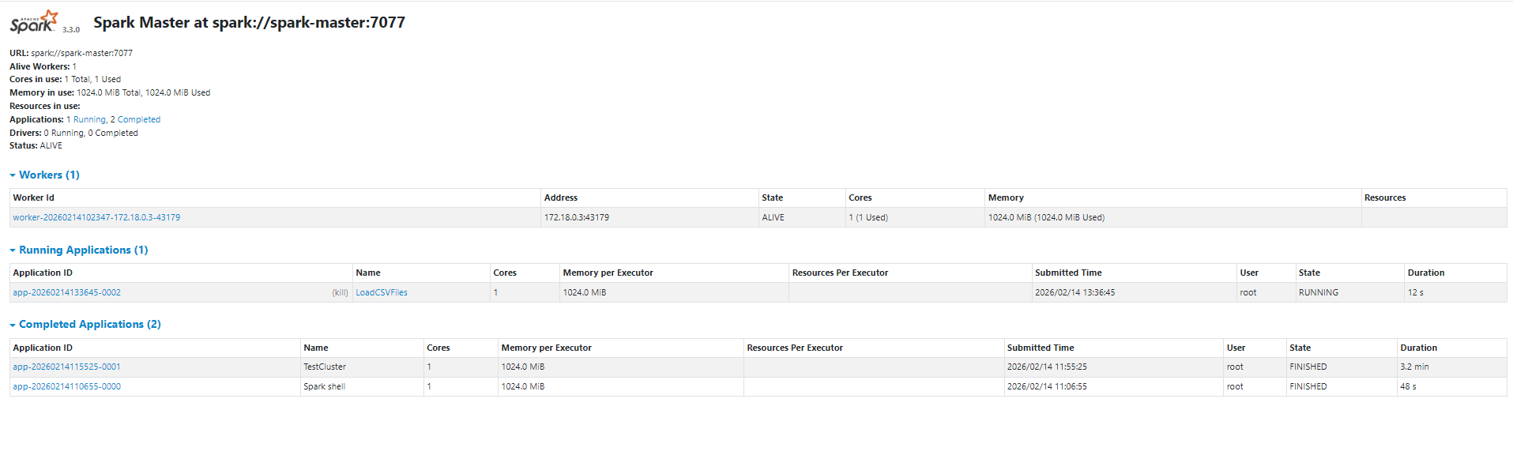
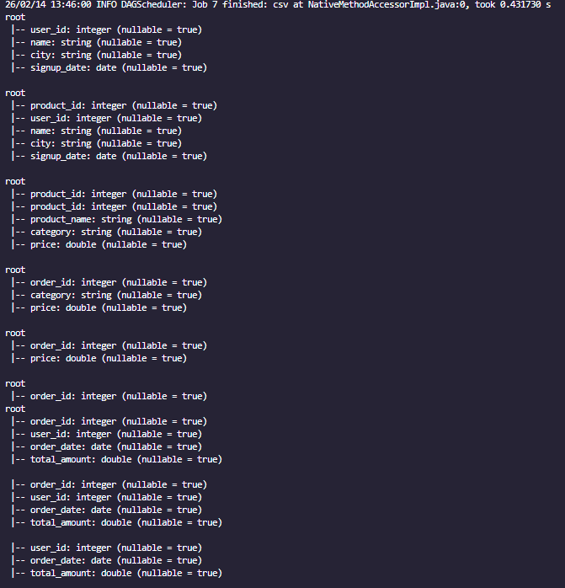
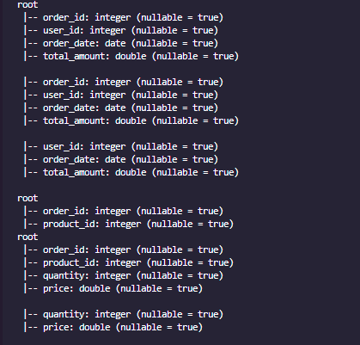

Source code
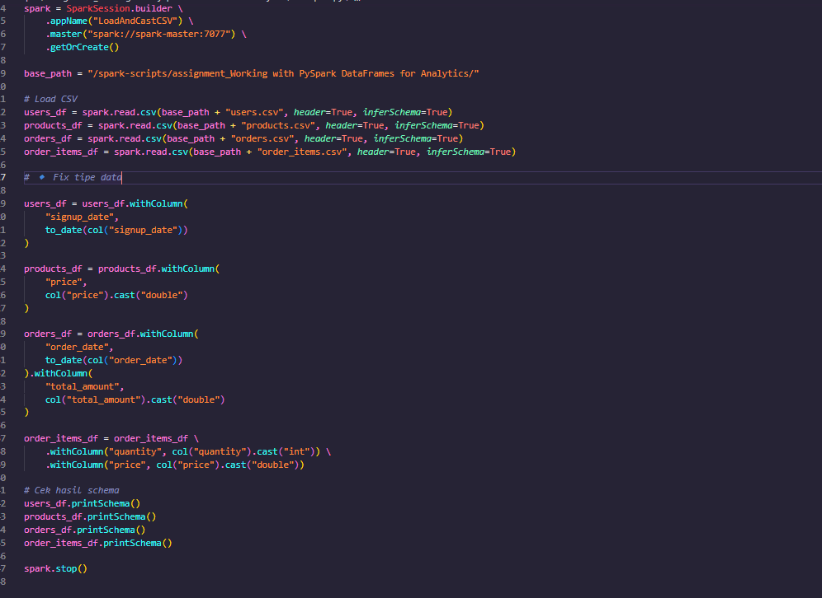
Perintah 2:
Lakukan data profiling ringkas:
- jumlah baris tiap DataFrame,
- cek null per kolom,
- tampilkan 5 contoh baris tiap dataset.
- def data_profiling(df, df_name):
- print(f"\n===== DATA PROFILING: {df_name} =====")
- total_rows = df.count()
- print(f"Total Rows: {total_rows}")
- print("\nNull Count per Column:")
- df.select([
- count(when(col(c).isNull(), c)).alias(c)
- for c in df.columns
- ]).show()
- print("\nSample Data:")
- df.show(5)

- # Jalankan profiling untuk semua dataset
- data_profiling(users_df, "USERS")
- data_profiling(products_df, "PRODUCTS")
- data_profiling(orders_df, "ORDERS")
- data_profiling(order_items_df, "ORDER_ITEMS")

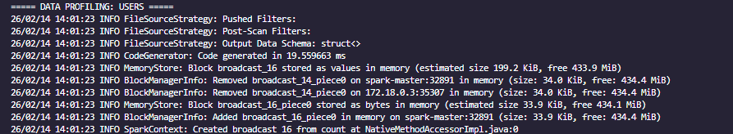
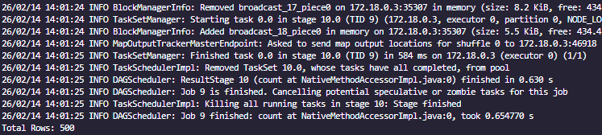

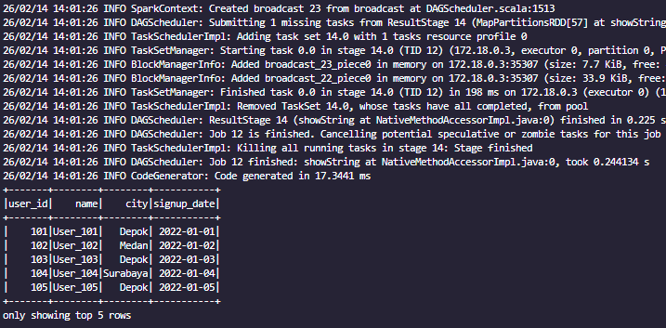

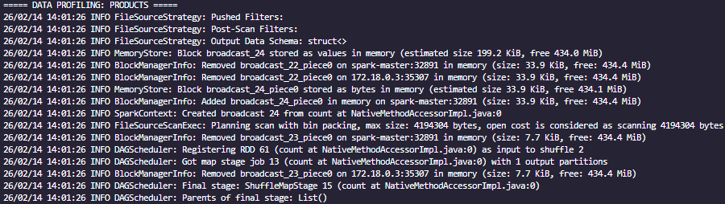
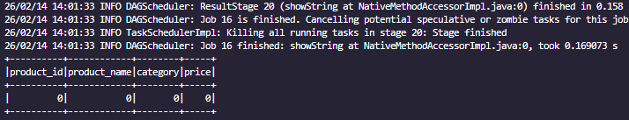
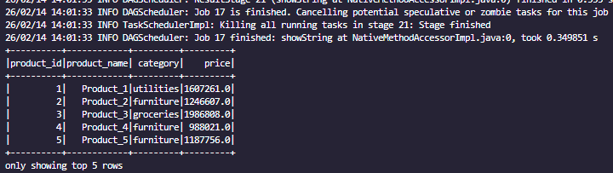

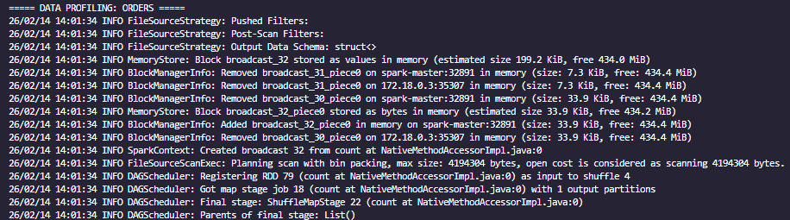
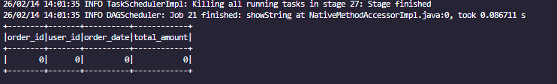
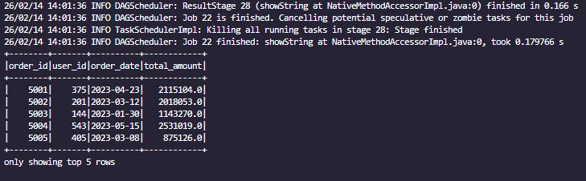

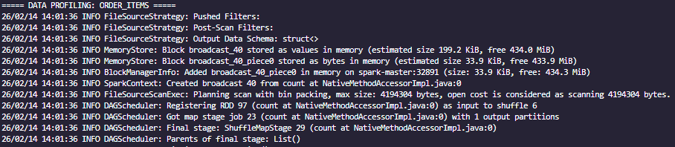
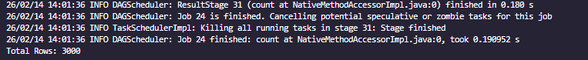
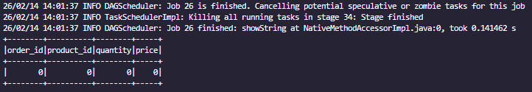
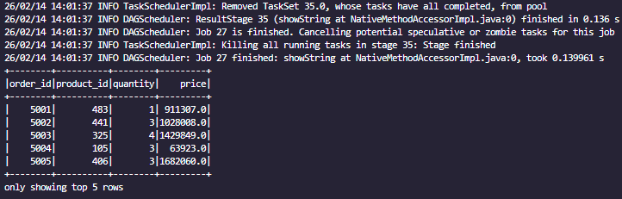

Perintah 3:
Buat “anomaly summary” awal:
- jumlah orders dengan total_amount <= 0,
- jumlah order_items dengan quantity <= 0 atau price <= 0,
- jumlah duplikasi key utama (order_id di orders, product_id di products, user_id di users).
- print("\n===== ANOMALY SUMMARY =====")

- # Orders dengan total_amount <= 0
- invalid_orders = orders_df.filter(col("total_amount") <= 0).count()
- print(f"Jumlah orders dengan total_amount <= 0: {invalid_orders}")

- # Order_items dengan quantity <= 0 atau price <= 0
- invalid_order_items = order_items_df.filter(
- (col("quantity") <= 0) | (col("price") <= 0)
- ).count()
- print(f"Jumlah order_items dengan quantity <= 0 atau price <= 0: {invalid_order_items}")

- # Duplikasi primary key
- # a) Duplicate order_id
- duplicate_orders = orders_df.groupBy("order_id") \
- .count() \
- .filter(col("count") > 1) \
- .count()
- print(f"Jumlah duplikasi order_id di orders: {duplicate_orders}")
- # b) Duplicate product_id
- duplicate_products = products_df.groupBy("product_id") \
- .count() \
- .filter(col("count") > 1) \
- .count()
- print(f"Jumlah duplikasi product_id di products: {duplicate_products}")
- # c) Duplicate user_id
- duplicate_users = users_df.groupBy("user_id") \
- .count() \
- .filter(col("count") > 1) \
- .count()
- print(f"Jumlah duplikasi user_id di users: {duplicate_users}")
- spark.stop()

SOAL 2 — Cleaning & Standardization
Perintah 1:
Bersihkan data:
- drop baris orders yang order_id atau user_id null,
- drop baris order_items yang order_id atau product_id null,
- drop baris products yang product_id null,
- drop baris users yang user_id null.
- print("\n===== CLEANING & STANDARDIZATION =====")

- # Simpan jumlah awal
- initial_users = users_df.count()
- initial_products = products_df.count()
- initial_orders = orders_df.count()
- initial_order_items = order_items_df.count()

- # Drop orders jika order_id atau user_id null
- orders_clean = orders_df.dropna(subset=["order_id", "user_id"])

- # Drop order_items jika order_id atau product_id null
- order_items_clean = order_items_df.dropna(subset=["order_id", "product_id"])

- # Drop products jika product_id null
- products_clean = products_df.dropna(subset=["product_id"])

- # Drop users jika user_id null
- users_clean = users_df.dropna(subset=["user_id"])

- # Hitung setelah cleaning
- final_users = users_clean.count()
- final_products = products_clean.count()
- final_orders = orders_clean.count()
- final_order_items = order_items_clean.count()

- # Buat summary table supaya mudah di screenshot
- summary_data = [
- ("users", initial_users, final_users, initial_users - final_users),
- ("products", initial_products, final_products, initial_products - final_products),
- ("orders", initial_orders, final_orders, initial_orders - final_orders),
- ("order_items", initial_order_items, final_order_items, initial_order_items - final_order_items),
- ]

- summary_df = spark.createDataFrame(
- summary_data,
- ["dataset", "rows_before", "rows_after", "rows_dropped"]
- )

- summary_df.show(truncate=False)

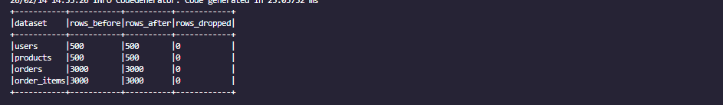
Perintah 2:
Standardisasi kolom teks:
- city di users → lowercase + trim,
- category di products → lowercase + trim.
- print("\n===== STANDARDIZATION =====")
- # Standardisasi users.city
- users_std = users_clean.withColumn(
- "city",
- trim(lower(col("city")))
- )
- # Standardisasi products.category
- products_std = products_clean.withColumn(
- "category",
- trim(lower(col("category")))
- )
- # Untuk dataset lain tetap pakai hasil cleaning
- orders_std = orders_clean
- order_items_std = order_items_clean
- # Buat ringkasan hasil standardisasi untuk screenshot
- print("\nSample USERS after standardization:")
- users_std.select("user_id", "city").show(5, truncate=False)
- print("\nSample PRODUCTS after standardization:")
- products_std.select("product_id", "category").show(5, truncate=False)

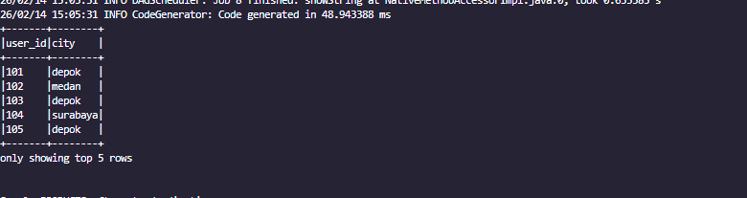
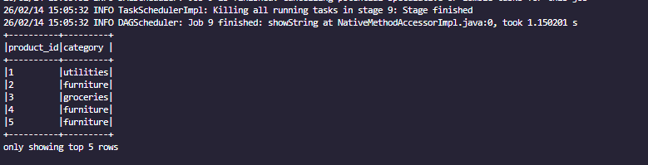
Perintah 3:
Deduplication berbasis key:
- orders dedupe by order_id,
- order_items dedupe by kombinasi (order_id,product_id),
- products dedupe by product_id,
users dedupe by user_id. Tunjukkan jumlah baris sebelum vs sesudah dedupe
print("\n===== DEDUPLICATION SUMMARY =====")

# Simpan jumlah sebelum dedupe
before_users = users_std.count()
before_products = products_std.count()
before_orders = orders_std.count()
before_order_items = order_items_std.count()

# orders dedupe by order_id
orders_dedup = orders_std.dropDuplicates(["order_id"])

# order_items dedupe by (order_id, product_id)
order_items_dedup = order_items_std.dropDuplicates(["order_id", "product_id"])

# products dedupe by product_id
products_dedup = products_std.dropDuplicates(["product_id"])

# users dedupe by user_id
users_dedup = users_std.dropDuplicates(["user_id"])

# Hitung setelah dedupe
after_users = users_dedup.count()
after_products = products_dedup.count()
after_orders = orders_dedup.count()
after_order_items = order_items_dedup.count()

# Buat summary table
dedupe_summary = [
("users", before_users, after_users, before_users - after_users),
("products", before_products, after_products, before_products - after_products),
("orders", before_orders, after_orders, before_orders - after_orders),
("order_items", before_order_items, after_order_items, before_order_items - after_order_items),
]

dedupe_summary_df = spark.createDataFrame(
dedupe_summary,
["dataset", "rows_before", "rows_after", "rows_removed"]
)

dedupe_summary_df.show(truncate=False)

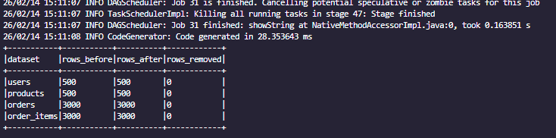

SOAL 3 — Data Enrichment & Feature Engineering
Perintah 1:
Di order_items, buat kolom turunan:
- total_item_value = quantity * price.
- print("\n===== FEATURE ENGINEERING: total_item_value =====")

- order_items_enriched = order_items_dedup.withColumn(
- "total_item_value",
- col("quantity") * col("price")
- )

- # Tampilkan contoh hasil
- order_items_enriched.select(
- "order_id",
- "product_id",
- "quantity",
- "price",
- "total_item_value"
- ).show(5, truncate=False)
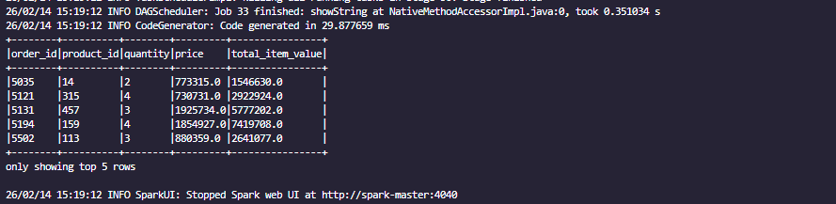
Perintah 2:
Di orders, buat kolom kategorisasi menggunakan when/otherwise:
- order_value_flag dengan aturan:
high_value jika total_amount > 500000, selain itu normal.
- print("\n===== FEATURE ENGINEERING: order_value_flag =====")

- orders_enriched = orders_dedup.withColumn(
- "order_value_flag",
- when(col("total_amount") > 500000, "high_value")
- .otherwise("normal")
- )

- # Tampilkan contoh hasil
- orders_enriched.select(
- "order_id",
- "total_amount",
- "order_value_flag"
- ).show(10, truncate=False)
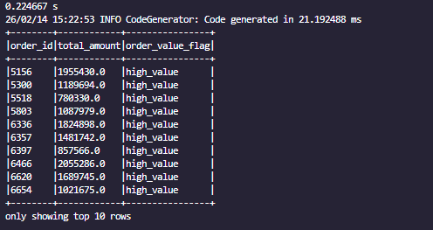
Perintah 3:
Buat kolom segmentasi user di users:
- user_tenure_days = datediff(order_date_max_per_user, signup_date) (Hint: butuh join/agg kecil untuk order_date_max_per_user).
tenure_segment = new (<=30 hari), mature (31–180), loyal (>180).
- # Ambil order_date maksimal per user
- order_date_max = orders_enriched.groupBy("user_id") \
- .agg(max("order_date").alias("order_date_max_per_user"))
- users_joined = users_dedup.join(
- order_date_max,
- on="user_id",
- how="left"
- )
- users_with_tenure = users_joined.withColumn(
- "user_tenure_days",
- datediff(col("order_date_max_per_user"), col("signup_date"))
- )

- users_final = users_with_tenure.withColumn(
- "tenure_segment",
- when(col("user_tenure_days") <= 30, "new")
- .when((col("user_tenure_days") > 30) & (col("user_tenure_days") <= 180), "mature")
- .when(col("user_tenure_days") > 180, "loyal")
- .otherwise("no_order")
- )
- users_final.select(
- "user_id",
- "signup_date",
- "order_date_max_per_user",
- "user_tenure_days",
- "tenure_segment"
- ).show(10, truncate=False)

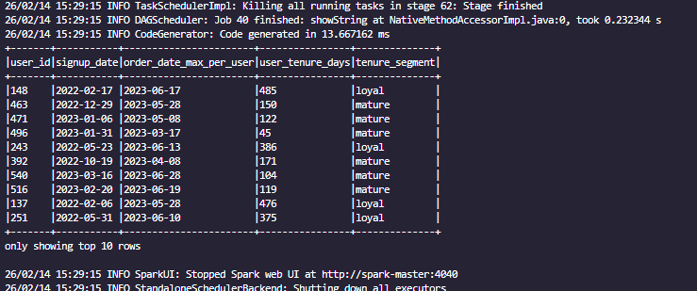

SOAL 4 — Join & Aggregation (Business Metrics)
Perintah 1:
Bangun DataFrame “fact” hasil join:
orders ⟷ order_items ⟷ products ⟷ users
dengan key:
- orders ↔ order_items: order_id
- order_items ↔ products: product_id
- orders ↔ users: user_id
Perintah 2:
Hitung metrik per category per day:
- daily_gmv_category = sum(total_item_value)
- daily_orders_category = countDistinct(order_id)
- daily_items_sold = sum(quantity)
Urutkan per hari dan GMV terbesar.
Perintah 3:
Hitung metrik per city:
- total GMV kota,
- AOV kota (avg total_amount),
- jumlah customer unik kota,
- top 3 kategori kontribusi terbesar per kota (boleh pakai window rank).
- # ==============================
- # BUILD FACT TABLE
- # ==============================
- fact_df = orders \
- .join(order_items, on="order_id", how="inner") \
- .join(products, on="product_id", how="inner") \
- .join(users, on="user_id", how="inner")

- # ==============================
- # DAILY METRICS PER CATEGORY
- # ==============================
- daily_category_metrics = fact_df.groupBy(
- "order_date",
- "category"
- ).agg(
- sum("total_item_value").alias("daily_gmv_category"),
- countDistinct("order_id").alias("daily_orders_category"),
- sum("quantity").alias("daily_items_sold")
- ).orderBy(
- "order_date",
- col("daily_gmv_category").desc()
- )

- print("\n===== DAILY METRICS PER CATEGORY =====")
- daily_category_metrics.show(50, truncate=False)

- # ==============================
- # CITY LEVEL METRICS
- # ==============================
- city_metrics = fact_df.groupBy("city").agg(
- sum("total_item_value").alias("total_gmv_city"),
- avg("total_amount").alias("aov_city"),
- countDistinct("user_id").alias("unique_customers")
- ).orderBy(col("total_gmv_city").desc())

- print("\n===== CITY LEVEL METRICS =====")
- city_metrics.show(truncate=False)

- # ==============================
- # TOP 3 CATEGORY PER CITY
- # ==============================
- city_category_gmv = fact_df.groupBy(
- "city",
- "category"
- ).agg(
- sum("total_item_value").alias("gmv_per_category")
- )

- window_spec = Window.partitionBy("city") \
- .orderBy(col("gmv_per_category").desc())

- top3_category_city = city_category_gmv.withColumn(
- "rank",
- rank().over(window_spec)
- ).filter(col("rank") <= 3)

- print("\n===== TOP 3 CATEGORY PER CITY =====")
- top3_category_city.orderBy("city", "rank").show(truncate=False)
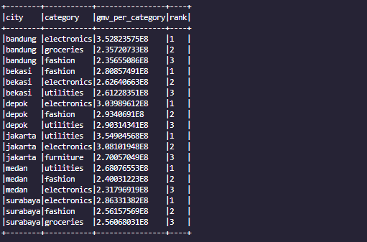

SOAL 5 — Window Analytics & Insight Final
Perintah 1:
Gunakan window function per user untuk membuat kolom:
- user_total_spending (sum total_amount per user),
- user_total_orders (count order per user),
- user_avg_order_value (avg total_amount per user),
- user_rank global berdasarkan user_total_spending (dense_rank).
Perintah 2:
Buat analisis cumulative GMV harian:
- gmv_daily,
- cumulative_gmv (sum gmv_daily over order by date).
Perintah 3:
Ambil Top 10 customers (rank 1–10) dan tampilkan:
user_id, name, city, user_total_orders, user_total_spending, user_avg_order_value.
Tambahkan interpretasi singkat 4–6 kalimat: pola apa yang kamu lihat? (misal kota dominan, AOV tinggi tapi order sedikit, dll).
# ==============================
# WINDOW ANALYTICS PER USER
# ==============================
print("\n===== WINDOW ANALYTICS PER USER =====")

user_metrics = fact_df.groupBy(
"user_id",
"name",
"city"
).agg(
sum("total_amount").alias("user_total_spending"),
countDistinct("order_id").alias("user_total_orders"),
avg("total_amount").alias("user_avg_order_value")
)

rank_window = Window.orderBy(col("user_total_spending").desc())

user_metrics = user_metrics.withColumn(
"user_rank",
dense_rank().over(rank_window)
)

user_metrics.orderBy("user_rank").show(20, truncate=False)

# ==============================
# CUMULATIVE GMV DAILY
# ==============================
print("\n===== CUMULATIVE GMV DAILY =====")

gmv_daily = fact_df.groupBy("order_date") \
.agg(sum("total_item_value").alias("gmv_daily")) \
.orderBy("order_date")

cumulative_window = Window.orderBy("order_date") \
.rowsBetween(Window.unboundedPreceding, Window.currentRow)

gmv_daily = gmv_daily.withColumn(
"cumulative_gmv",
sum("gmv_daily").over(cumulative_window)
)

gmv_daily.show(50, truncate=False)

# ==============================
# TOP 10 CUSTOMERS
# ==============================
print("\n===== TOP 10 CUSTOMERS =====")

top10_customers = user_metrics \
.filter(col("user_rank") <= 10) \
.orderBy("user_rank")

top10_customers.select(
"user_id",
"name",
"city",
"user_total_orders",
"user_total_spending",
"user_avg_order_value"
).show(truncate=False)

